Trustworthy and Reliable Deep-Learning-Based Cyberattack Detection in Industrial IoT
- INTRODUCTION:
The Industrial Internet of Things (IIoT) is a pervasive network that connects a diverse set of smart appliances in the industrial environment to deliver various intelligent services. In IIoT networks, a significant amount of industrial control systems (ICSs) premised on supervisory control and data acquisition (SCADA) are linked to the corporate network through the Internet . Typically, these SCADA-based IIoT networks consist of a large number of field devices, for instance, intelligent electronic devices, sensors, and actuators, connected to an enterprise network via heterogeneous communications. This integration provides the industrial networks and systems with supervision and a lot of flexibility and agility, resulting in greater production and resource efficiency. On the other hand, this integration exposes SCADA-based IIoT networks to serious security threats and vulnerabilities, posing a significant danger to these networks and the trustworthiness of the systems. The trustworthiness of an IIoT-enabled system ensures that it performs as expected while meeting a variety of security requirements, including trust, security, safety, reliability, resilience, and privacy. Fig. 1 depicts the fundamental aspects of trustworthiness in an IIoT-enabled network. The basic goal of the IIoT-enabled system is to increase trustworthiness by safeguarding identities, data, and services, and therefore to secure SCADA-based IIoT networks from cybercriminals. Several protocol updates have been proposed to meet this purpose, including the distributed network protocol (DNP 3.0) . However, it covers authentication and data integrity aspects only, leaving numerous holes for attackers to use known flaws like hash collision to carry out serious attacks. Information Technology and Industrial Operational technology bodies build a typical risk management plan utilizing ISO 27005:2018 [10] 1551-3203 © 2022 IEEE. Personal use is permitted, but republication/redistribution requires IEEE permission. See https://www.ieee.org/publications/rights/index.html for more information. Authorized licensed use limited to: The University of Toronto. Downloaded on December 15,2022 at 07:45:56 UTC from IEEE Xplore. Restrictions apply. e-tarjome.com KHAN et al.: TRUSTWORTHY AND RELIABLE DEEP-LEARNING-BASED CYBERATTACK DETECTION IN INDUSTRIAL IOT 1031 Fig. 1. Security and trustworthiness goals and CIA triad. to recognize, rank, and implement alleviation techniques in automated or semiautomated enterprises. A comprehensive risk management plan and adequate preventive measures may not ensure absolute security against growing risks and attacks. This consequently offers a difficult research challenge for industrial and cybersecurity control researchers to 1) obtain the maximum degree of attack detection, 2) report malicious behavior as soon as it appears, and 3) isolate the afflicted subsystems as soon as possible. In recent years, there has been a surge toward the utility of artificial intelligence (AI) methods in evolving cybersecurity approaches, including attack prediction, privacy preservation, forensic exploration, and malware disclosure. Deep learning (DL) is an AI approach that incorporates better learning models with considerable success in various disciplines. However, designing a reliable and trustworthy AI, particularly a DL-based cyberattack detection model for the IoT platforms, remains a research problem. By considering the limitations of previous techniques, we employ network attributes of industrial protocols and propose a pyramidal recurrent unit (PRUs)- and decision tree (DT)-based ensemble detection mechanism. The proposed mechanism has the potential to detect cyberattacks in any extensive industrial network. The interoperability with other detection engines and expandability for a wider industrial network with multiple areas distinguishes the proposed mechanism from previous studies. The proposed detection method is Disse minable across many IoT domains. Furthermore, our model is straightforward to implement and deploy and can improve efficiency and accuracy while overcoming the shortcomings of previous efforts. The following capabilities can characterize the novelty and contribution of our article
1.1 Objective of the project:
A fundamental expectation of the stakeholders from the Industrial Internet of Things (IIoT) is its trustworthiness and sustainability to avoid the loss of human lives in performing a critical task. A trustworthy IIoT-enabled network encompasses fundamental security characteristics, such as trust, privacy, security, reliability, resilience, and safety. The traditional security mechanisms and procedures are insufficient to protect these networks owing to protocol differences, limited update options, and older adaptations of the security mechanisms. As a result, these networks require novel approaches to increase trustlevel and enhance security and privacy mechanisms. Therefore, in this article, we propose a novel approach to improve the trustworthiness of IIoT-enabled networks. We propose an accurate and reliable supervisory control and data acquisition (SCADA) network-based cyberattack detection in these networks. The proposed scheme combines the deeplearning-based pyramidal recurrent units (PRU) and decision tree (DT) with SCADA-based IIoT networks. We also use an ensemble-learning method to detect cyberattacks in SCADA-based IIoT networks. The nonlinear learning ability of PRU and the ensemble DT address the sensitivity of rrelevant features, allowing high detection rates. The proposed scheme is evaluated on 15 datasets generated from SCADA-based networks. The experimental results show that the proposed scheme outperforms traditional methods and machine learning-based detection approaches. The proposed scheme improves the security and associated measure of trustworthiness in IIoT-enabled networks

2. LITERATURE SURVEY:
“Nonlinear dimensionality reduction for intrusion detection using auto-encoder bottleneck features”
The continuous advances in technology is the reason of integration of our lives and information systems. Due to this fact the importance of security in these systems increases. Therefore, the application of intrusion detection systems as security solutions is increasing year by year. These systems (IDSs) are considered as a way of protection against cyber-attacks. However, handling big data constitutes one of the main challenges of intrusion detection systems and is the reason of low performance of these systems from the view of time and space complexity. To address these problems we have proposed an approach to reduce this complexity. Our approach is based on dimensionality reduction and the neural network bottleneck feature extraction is considered as the main method in this research. We have conducted several experiments on a benchmark dataset (NSL-KDD) to investigate the effectiveness of our approach. The results show that our approach is promising in terms of accuracy for real-world intrusion detection.
“Deep learning approach combining sparse autoencoder with svm for network intrusion detection”
Network intrusion detection systems (NIDSs) provide a better solution to network security than other traditional network defense technologies, such as firewall systems. The success of NIDS is highly dependent on the performance of the algorithms and improvement methods used to increase the classification accuracy and decrease the training and testing times of the algorithms. We propose an effective deep learning approach, self-taught learning (STL)-IDS, based on the STL framework. The proposed approach is used for feature learning and dimensionality reduction. It reduces training and testing time considerably and effectively improves the prediction accuracy of support vector machines (SVM) with regard to attacks. The proposed model is built using the sparse autoencoder mechanism, which is an effective learning algorithm for reconstructing a new feature representation in an unsupervised manner. After the pre-training stage, the new features are fed into the SVM algorithm to improve its detection capability for intrusion and classification accuracy. Moreover, the efficiency of the approach in binary and multiclass classification is studied and compared with that of shallow classification methods, such as J48, naive Bayesian, random forest, and SVM. Results show that our approach has accelerated SVM training and testing times and performed better than most of the previous approaches in terms of performance metrics in binary and multiclass classification. The proposed STL-IDS approach improves network intrusion detection and provides a new research method for intrusion detection.
“Destin: A scalable deep learning architecture with application to high-dimensional robust pattern recognition”
The topic of deep learning systems has received significant attention during the past few years, particularly as a biologically-inspired approach to processing highdimensional signals. The latter often involve spatiotemporal information that may span large scales, rendering its representation in the general case highly challenging. Deep learning networks attempt to overcome this challenge by means of a hierarchical architecture that is comprised of common circuits with similar (and often cortically influenced) functionality. The goal of such systems is to represent sensory observations in a manner that will later facilitate robust pattern classification, mimicking a key attribute of the mammal brain. This stands in contrast with the mainstream approach of pre-processing the data so as to reduce its dimensionality — a paradigm that often results in sub-optimal performance. This paper presents a Deep SpatioTemporal Inference Network (DeSTIN) — a scalable deep learning architecture that relies on a combination of unsupervised learning and Bayesian inference. Dynamic pattern learning forms an inherent way of capturing complex spatiotemporal dependencies. Simulation results demonstrate the core capabilities of the proposed framework, particularly in the context of high-dimensional signal classification.
“A challenge for network traffic analytics.”
Classifying network traffic is the basis for important network applications. Prior research in this area has faced challenges on the availability of representative datasets, and many of the results cannot be readily reproduced. Such a problem is exacerbated by emerging data-driven machine learning based approaches. To address this issue, we provide three open datasets containing almost 1.3M labeled flows in total, with flow features and anonymized raw packets, for the research community. We focus on broad aspects in network traffic analysis, including both malware detection and application classification. We release the datasets in the form of an open challenge called NetML1 and implement several machine learning methods including random-forest, SVM and MLP. As we continue to grow NetML, we expect the datasets to serve as a common platform for AI driven, reproducible research on network flow analytics.
“A Survey of Deep Learning Methods for Cyber Security.”
This survey paper describes a literature review of deep learning (DL) methods for cyber security applications. A short tutorial-style description of each DL method is provided, including deep autoencoders, restricted Boltzmann machines, recurrent neural networks, generative adversarial networks, and several others. Then we discuss how each of the DL methods is used for security applications. We cover a broad array of attack types including malware, spam, insider threats, network intrusions, false data injection, and malicious domain names used by botnets.
“Mobile agents for detecting network attacks using timing covert channels”
This article addresses the problem of network attacks using steganographic techniques based on the manipulation of time relationships between IP packets. In the study, an efficient method to detect such attacks is presented. The proposed algorithm is based on the Change Observation Theory, and employs two types of agents: base and flying ones. The agents observe the time parameters of the network traffic, using proposed meta-histograms and trained machine learning algorithms, in the node where they were installed. The results of experiments using various machine learning algorithm are presented and discussed. The study showed that the Random Forest and MLP classifiers achieved the best detection results, yielding an area under the ROC curve (AUC) above 0.85 for the evaluation data. We showed a proof-of-concept for an attack detection method that combined the classification algorithm, the proposed anomaly metrics and the mobile agents. We claim that due to a unique feature of self-regulation, realized by destroying unnecessary agents, the proposed method can establish a new type of multi-agent intrusion detection system that can be applied to a wider group of IT systems
“Advanced analysis of data streams for critical infrastructures protection and cyber security”
Cyber threats are nowadays a major danger to critical infrastructures and to homeland security. For several years now, the focus have been targeted at the physical protection of critical infrastructures. Currently, experts realize that the critical infrastructure can be also attacked via the application layer of computer networks. In order to efficiently protect such critical systems, the huge amount of data has to be efficiently analyzed and correlated. Therefore, this paper focuses on the overview of the advanced data stream processing methods to be applied in the domain of cybersecurity and critical infrastructure protection. The major contribution of this work is the analysis of such innovative aspects as concept drift analysis deployed as the pre-processing step dedicated for anomaly detection systems to counter cyber attacks. Moreover, we discuss the different challenges in data streams analysis including data imbalance and provide solid reasoning why applying a concept drift detector is crucial when designing a modern cyber security systems
“Internet of things: A survey on machine learningbased intrusion detection approaches”
In the world scenario, concerns with security and privacy regarding computer networks are always increasing. Computer security has become a necessity due to the proliferation of information technologies in everyday life. The increase in the number of Internet accesses and the emergence of new technologies, such as the Internet of Things (IoT paradigm, are accompanied by new and modern attempts to invade computer systems and networks. Companies are increasingly investing in studies to optimize the detection of these attacks. Institutions are selecting intelligent techniques to test and verify by comparing the best rates of accuracy. This research, therefore, focuses on rigorous state-of-the-art literature on Machine Learning Techniques applied in Internet-of-Things and Intrusion Detection for computer network security. The work aims, therefore, recent and in-depth research of relevant works that deal with several intelligent techniques and their applied intrusion detection architectures in computer networks with emphasis on the Internet of Things and machine learning. More than 95 works on the subject were surveyed, spanning across different themes related to security issues in IoT environments.
“Malware detection in mobile environments based on Autoencoders and API-images.”
Due to their open nature and popularity, Android-based devices represent one of the main targets for malware attacks that may adversely affect the privacy of their users. Considering the huge Android market share, it is necessary to build effective tools able to reliably detect zero-day malware on these platforms. Therefore, several static and dynamic analysis methods based on Neural Networks and Deep Learning have been proposed in the literature. Despite machine learning can be considered the most promising approach for classifying applications into malware or legitimate ones, its success strongly depends on the choice of the right features used for building the detection model. This is definitely not an easy task that requires a systematic solution. Accordingly, this work represents the sequences of API calls invoked by apps during their execution as sparse matrices looking like images (API-images), which can be used as fingerprints of the apps’ behavior over time. We also used autoencoders to autonomously extract the most representative and discriminating features from these matrices, that, once provided to an artificial neural network-based classifier have shown to be effective in detecting malware, also when the network is trained on a reduced number of samples. Experimental results show that the resulting framework is able to outperform more complex and sophisticated machine learning approaches in malware classification.
“Network traffic classification using deep convolutional recurrent autoencoder neural networks for spatial–temporal features extraction”
The right choice of features to be extracted from individual or aggregated observations is an extremely critical factor for the success of modern network traffic classification approaches based on machine learning. Such activity, usually in charge of the designers of the classification scheme is strongly related to their experience and skills, and definitely characterizes the whole approach, implementation strategy as well as its performance. The main aim of this work is supporting this process by mining new and more expressive, meaningful and discriminating features from the basic ones without human intervention. For this purpose, a novel autoencoder-based deep neural network architecture is proposed where multiple autoencoders are embedded with convolutional and recurrent neural networks to elicit relevant knowledge about the relations existing among the basic features (spatial-features) and their evolution over time (temporal-features). Such knowledge, consisting in new properties that are not immediately evident and better represent the most hidden and representative traffic dynamics can be successfully exploited by machine learning-based classifiers. Different network combinations are analyzed both from a theoretical perspective, and through specific performance evaluation experiments on a real network traffic dataset. We show that the traffic classifier obtained by stacking the autoencoder with a fully-connected neural network, achieves up to a 28% improvement in average accuracy over state-of-the-art machine learning-based approaches, up to a 10% over pure convolutional and recurrent stacked neural networks, and 18% over pure feed-forward networks. It is also able to maintain high accuracy even in the presence of unbalanced training datasets.
3. SYSTEM ANALYSIS
3.1 Existing System
In Existing system using Decision Tree Algorithm Careful cybercriminals will go to great lengths to hide their identity and their location. As well as using online pseudonyms known as 'handles', they will often do business on the dark web, which makes it hard to track them A lot of national and federal agencies use interviews and surveillance reports to obtain proof of cybercrime. Surveillance involves not only security cameras, videos and photos, but also electronic device surveillance that details what's being used and when, how it's being used, and all the digital behavior involved
Disadvantages of Existing System:
- Less Accuracy
3.2 Proposed System
In this project author is applying Machine Learning Neural Network algorithm to detect attacks from IOT networks as IOT are small devices which will sense data from environment and using internet connection will send sense data to base station or centralized servers and sometime attackers may hijack or intrude the data transfer and inject false or incorrect information and to overcome from this problem we are training Neural Network algorithm with IOT traces dataset and whenever new test packet arrived then neural network will predict whether that packet is normal or contain attack signatures.

Advantages of Proposed System:
- More Accuracy
Modules Information:
To implement this project we have designed following modules
- Upload IOT Cyber Attack Dataset: using this module we will upload IOT dataset to application
- Preprocess Dataset: using this module we will read dataset and then replace missing values and then convert non-numeric data to numeric ID’s as machine learning algorithm will not take non-numeric data so we will transform all non-numeric data to numeric ID.
- Run Features Selection Algorithm: using this module we will run PCA features selection algorithm to select important attributes or columns from the dataset and then split dataset into train and test where application used 80% dataset for training and 20% for testing
- Run Deep Learning Neural Network: we will input above processed train data to deep learning algorithm to train neural network model and this model will be applied on test packet to predict it as normal or attack
- Run Random Forest Classification Algorithm: using this module we will train Random Forest algorithm
- Predict Attack from Test Data: using this module we will upload test data and then neural network model will predict attack from it

FUNCTIONAL REQUIREMENTS:
SOFTWARE REQIREMENTS:
System Attributes:
- X_train, X_test, y_train, y_test, pca, classifier
- dataset
- filename
- X, Y, label_encoder, imputer, imputer1
Data base Requirements:
No need
USECASE:
Use cases - Use cases describe the interaction between the system and external users that leads to achieving particular goals.
- Upload IOT Cyber Attack Dataset
- Preprocess Dataset
- Run Features Selection Algorithm
- Run Deep Learning Neural Network
- Run Random Forest Classification Algorithm
- Predict Attack from Test Data
User Stories: we can see IOT traces data and after arrow symbol we can see predicted output as NORMAL or attack name. So by using machine learning algorithm we can predict 99% attacks accurately
Work down Structure:
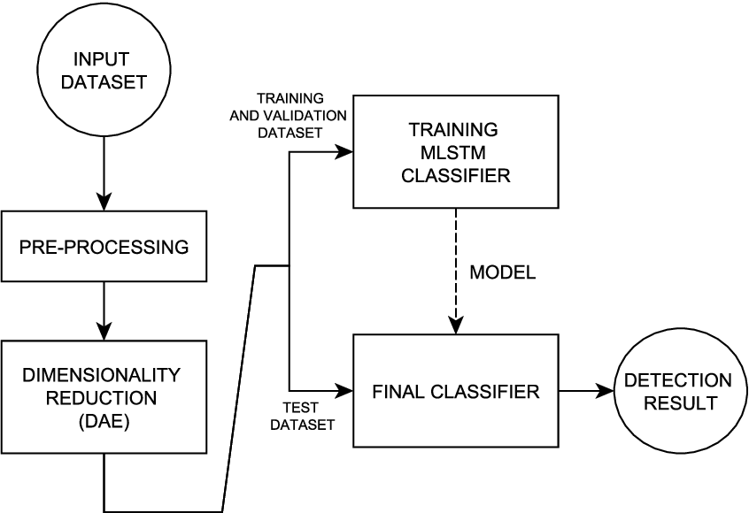

Prototype:
python 3.7.0 or 3.7.4
opencv-python==4.5.1.48
keras==2.3.1
tensorflow==1.14.0
protobuf==3.16.0
h5py==2.10.0
sklearn-extensions==0.0.2
scikit-learn==0.22.2.post1
Numpy
Pandas

Models and Diagrams:
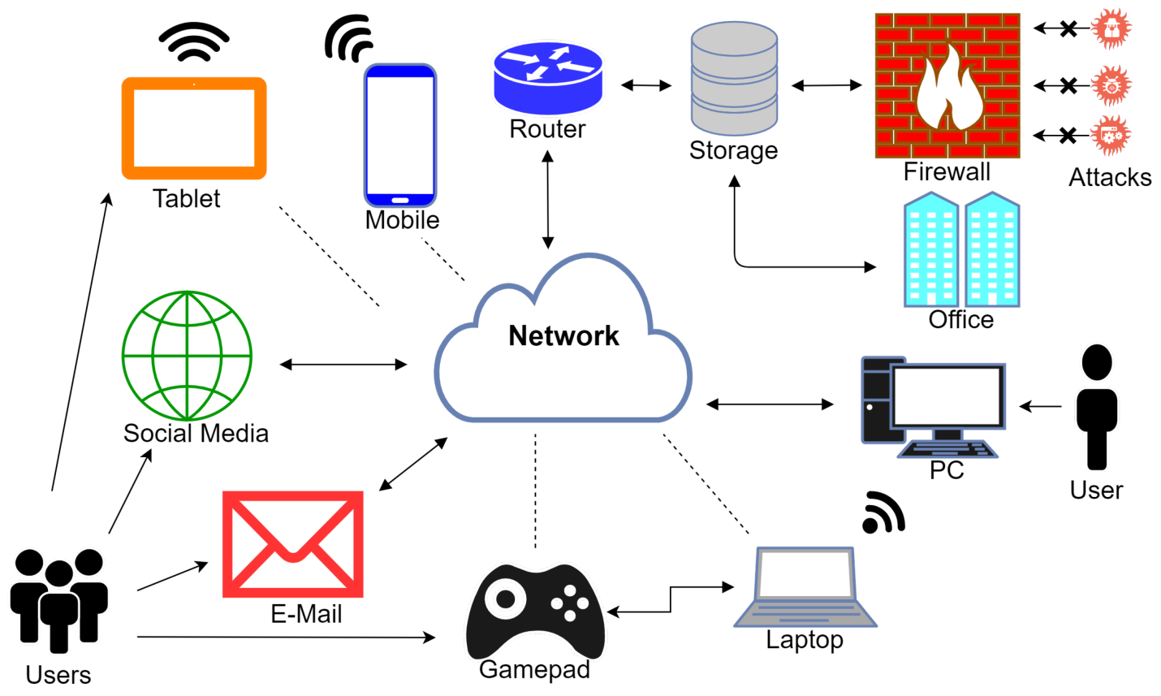

NON-FUNCTIONAL REQUIREMENT:
Usability: Usability is a quality attribute that assesses how easy user interfaces are to use. The word "usability" also refers to methods for improving ease-of-use during the design process.(how it was handle entire project easy)
Security: the quality or state of being secure: such as. a : freedom from danger : safety. b : freedom from fear or anxiety. c : freedom from the prospect of being laid off job security.
Readability: Readability is the ease with which a reader can understand a written text.
Performance: the execution of an action. : something accomplished : deed, feat. : the fulfillment of a claim, promise, or request : implementation. 3. : the action of representing a character in a play.
Availability: the quality or state of being available trying to improve the availability of affordable housing. 2 : an available person or thing.
Scalability: Scalability is the measure of a system's ability to increase or decrease in performance and cost in response to changes in application and system processing demands.

3.3. PROCESS MODEL USED WITH JUSTIFICATION
SDLC (Umbrella Model):
Umbrella Activity
Umbrella Activity
Umbrella Activity
- Feasibility Study
- TEAM FORMATION
- Project Specification PREPARATION

Business Requirement Documentation
ANALYSIS & DESIGN
CODE
UNIT TEST
DOCUMENT CONTROL

ASSESSMENT

TRAINING
INTEGRATION & SYSTEM TESTING

DELIVERY/INSTALLATION
ACCEPTANCE TEST
Requirements Gathering
SDLC is nothing but Software Development Life Cycle. It is a standard which is used by software industry to develop good software.
Stages in SDLC:
- Requirement Gathering
- Analysis
- Designing
- Coding
- Testing
- Maintenance

Requirements Gathering stage:
The requirements gathering process takes as its input the goals identified in the high-level requirements section of the project plan. Each goal will be refined into a set of one or more requirements. These requirements define the major functions of the intended application, define operational data areas and reference data areas, and define the initial data entities. Major functions include critical processes to be managed, as well as mission critical inputs, outputs and reports. A user class hierarchy is developed and associated with these major functions, data areas, and data entities. Each of these definitions is termed a Requirement. Requirements are identified by unique requirement identifiers and, at minimum, contain a requirement title and textual description.
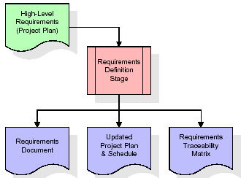
These requirements are fully described in the primary deliverables for this stage: the Requirements Document and the Requirements Traceability Matrix (RTM). The requirements document contains complete descriptions of each requirement, including diagrams and references to external documents as necessary. Note that detailed listings of database tables and fields are not included in the requirements document.
The title of each requirement is also placed into the first version of the RTM, along with the title of each goal from the project plan. The purpose of the RTM is to show that the product components developed during each stage of the software development lifecycle are formally connected to the components developed in prior stages.
In the requirements stage, the RTM consists of a list of high-level requirements, or goals, by title, with a listing of associated requirements for each goal, listed by requirement title. In this hierarchical listing, the RTM shows that each requirement developed during this stage is formally linked to a specific product goal. In this format, each requirement can be traced to a specific product goal, hence the term requirements traceability.
The outputs of the requirements definition stage include the requirements document, the RTM, and an updated project plan.
- Feasibility study is all about identification of problems in a project.
- No. of staff required to handle a project is represented as Team Formation, in this case only modules are individual tasks will be assigned to employees who are working for that project.
- Project Specifications are all about representing of various possible inputs submitting to the server and corresponding outputs along with reports maintained by administrator.
Analysis Stage:
The planning stage establishes a bird's eye view of the intended software product, and uses this to establish the basic project structure, evaluate feasibility and risks associated with the project, and describe appropriate management and technical approaches.
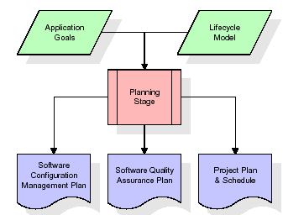
The most critical section of the project plan is a listing of high-level product requirements, also referred to as goals. All of the software product requirements to be developed during the requirements definition stage flow from one or more of these goals. The minimum information for each goal consists of a title and textual description, although additional information and references to external documents may be included. The outputs of the project planning stage are the configuration management plan, the quality assurance plan, and the project plan and schedule, with a detailed listing of scheduled activities for the upcoming Requirements stage, and high level estimates of effort for the out stages.

Designing Stage:
The design stage takes as its initial input the requirements identified in the approved requirements document. For each requirement, a set of one or more design elements will be produced as a result of interviews, workshops, and/or prototype efforts. Design elements describe the desired software features in detail, and generally include functional hierarchy diagrams, screen layout diagrams, tables of business rules, business process diagrams, pseudo code, and a complete entity-relationship diagram with a full data dictionary. These design elements are intended to describe the software in sufficient detail that skilled programmers may develop the software with minimal additional input.
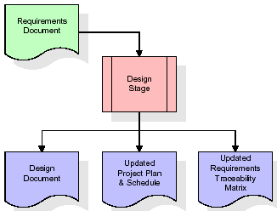
When the design document is finalized and accepted, the RTM is updated to show that each design element is formally associated with a specific requirement. The outputs of the design stage are the design document, an updated RTM, and an updated project plan.
Development (Coding) Stage:
The development stage takes as its primary input the design elements described in the approved design document. For each design element, a set of one or more software artifacts will be produced. Software artifacts include but are not limited to menus, dialogs, and data management forms, data reporting formats, and specialized procedures and functions. Appropriate test cases will be developed for each set of functionally related software artifacts, and an online help system will be developed to guide users in their interactions with the software.
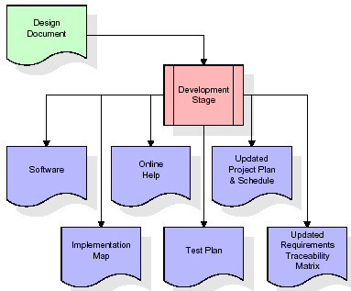

The RTM will be updated to show that each developed artifact is linked to a specific design element, and that each developed artifact has one or more corresponding test case items. At this point, the RTM is in its final configuration. The outputs of the development stage include a fully functional set of software that satisfies the requirements and design elements previously documented, an online help system that describes the operation of the software, an implementation map that identifies the primary code entry points for all major system functions, a test plan that describes the test cases to be used to validate the correctness and completeness of the software, an updated RTM, and an updated project plan.
Integration & Test Stage:
During the integration and test stage, the software artifacts, online help, and test data are migrated from the development environment to a separate test environment. At this point, all test cases are run to verify the correctness and completeness of the software. Successful execution of the test suite confirms a robust and complete migration capability. During this stage, reference data is finalized for production use and production users are identified and linked to their appropriate roles. The final reference data (or links to reference data source files) and production user list are compiled into the Production Initiation Plan.
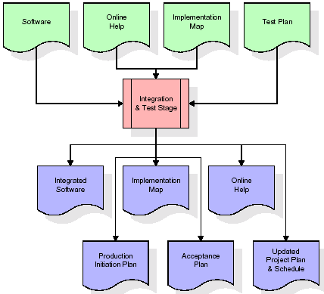
The outputs of the integration and test stage include an integrated set of software, an online help system, an implementation map, a production initiation plan that describes reference data and production users, an acceptance plan which contains the final suite of test cases, and an updated project plan.
- Installation & Acceptance Test:
During the installation and acceptance stage, the software artifacts, online help, and initial production data are loa ded onto the production server. At this point, all test cases are run to verify the correctness and completeness of the software. Successful execution of the test suite is a prerequisite to acceptance of the software by the customer.
After customer personnel have verified that the initial production data load is correct and the test suite has been executed with satisfactory results, the customer formally accepts the delivery of the software.
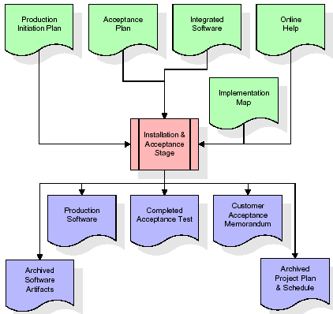
The primary outputs of the installation and acceptance stage include a production application, a completed acceptance test suite, and a memorandum of customer acceptance of the software. Finally, the PDR enters the last of the actual labor data into the project schedule and locks the project as a permanent project record. At this point the PDR "locks" the project by archiving all software items, the implementation map, the source code, and the documentation for future reference.

Maintenance:
Outer rectangle represents maintenance of a project, Maintenance team will start with requirement study, understanding of documentation later employees will be assigned work and they will undergo training on that particular assigned category. For this life cycle there is no end, it will be continued so on like an umbrella (no ending point to umbrella sticks).
3.4. Software Requirement Specification
3.4.1. Overall Description
A Software Requirements Specification (SRS) – a requirements specification for a software system is a complete description of the behavior of a system to be developed. It includes a set of use cases that describe all the interactions the users will have with the software. In addition to use cases, the SRS also contains non-functional requirements. Nonfunctional requirements are requirements which impose constraints on the design or implementation (such as performance engineering requirements, quality standards, or design constraints).
System requirements specification: A structured collection of information that embodies the requirements of a system. A business analyst, sometimes titled system analyst, is responsible for analyzing the business needs of their clients and stakeholders to help identify business problems and propose solutions. Within the systems development lifecycle domain, the BA typically performs a liaison function between the business side of an enterprise and the information technology department or external service providers. Projects are subject to three sorts of requirements:
- Business requirements describe in business terms what must be delivered or accomplished to provide value.
- Product requirements describe properties of a system or product (which could be one of several ways to accomplish a set of business requirements.)
- Process requirements describe activities performed by the developing organization. For instance, process requirements could specify .Preliminary investigation examine project feasibility, the likelihood the system will be useful to the organization. The main objective of the feasibility study is to test the Technical, Operational and Economical feasibility for adding new modules and debugging old running system. All system is feasible if they are unlimited resources and infinite time. There are aspects in the feasibility study portion of the preliminary investigation:
- ECONOMIC FEASIBILITY
A system can be developed technically and that will be used if installed must still be a good investment for the organization. In the economical feasibility, the development cost in creating the system is evaluated against the ultimate benefit derived from the new systems. Financial benefits must equal or exceed the costs. The system is economically feasible. It does not require any addition hardware or software. Since the interface for this system is developed using the existing resources and technologies available at NIC, There is nominal expenditure and economical feasibility for certain.
- Operational Feasibility
Proposed projects are beneficial only if they can be turned out into information system. That will meet the organization’s operating requirements. Operational feasibility aspects of the project are to be taken as an important part of the project implementation. This system is targeted to be in accordance with the above-mentioned issues. Beforehand, the management issues and user requirements have been taken into consideration. So there is no question of resistance from the users that can undermine the possible application benefits. The well-planned design would ensure the optimal utilization of the computer resources and would help in the improvement of performance status.
- TECHNICAL FEASIBILITY
Earlier no system existed to cater to the needs of ‘Secure Infrastructure Implementation System’. The current system developed is technically feasible. It is a web based user interface for audit workflow at NIC-CSD. Thus it provides an easy access to .the users. The database’s purpose is to create, establish and maintain a workflow among various entities in order to facilitate all concerned users in their various capacities or roles. Permission to the users would be granted based on the roles specified. Therefore, it provides the technical guarantee of accuracy, reliability and security.
3.4.2. External Interface Requirements
User Interface
The user interface of this system is a user friendly python Graphical User Interface.
Hardware Interfaces
The interaction between the user and the console is achieved through python capabilities.
Software Interfaces
The required software is python.
SYSTEM REQUIREMENT:
HARDWARE REQUIREMENTS:

Processor - Intel i3(min)
- Speed - 1.1 GHz
- RAM - 4GB(min)
- Hard Disk - 500 GB
- Key Board - Standard Windows Keyboard
- Mouse - Two or Three Button Mouse
- Monitor - SVGA
SOFTWARE REQUIREMENTS:
- Operating System - Windows10(min)
- Programming Language - Python

4. SYSTEM DESIGN
CLASS DIAGRAM:
The class diagram is the main building block of object oriented modeling. It is used both for general conceptual modeling of the systematic of the application, and for detailed modeling translating the models into programming code. Class diagrams can also be used for data modeling. The classes in a class diagram represent both the main objects, interactions in the application and the classes to be programmed. In the diagram, classes are represented with boxes which contain three parts:
- The upper part holds the name of the class
- The middle part contains the attributes of the class
- The bottom part gives the methods or operations the class can take or undertake

USECASE DIAGRAM:
A use case diagram at its simplest is a representation of a user's interaction with the system and depicting the specifications of a use case. A use case diagram can portray the different types of users of a system and the various ways that they interact with the system. This type of diagram is typically used in conjunction with the textual use case and will often be accompanied by other types of diagrams as we

SEQUENCE DIAGRAM
A sequence diagram is a kind of interaction diagram that shows how processes operate with one another and in what order. It is a construct of a Message Sequence Chart. A sequence diagram shows object interactions arranged in time sequence. It depicts the objects and classes involved in the scenario and the sequence of messages exchanged between the objects needed to carry out the functionality of the scenario. Sequence diagrams are typically associated with use case realizations in the Logical View of the system under development. Sequence diagrams are sometimes called event diagrams, event scenarios, and timing diagrams.

COLLABORATION DIAGRAM:
A collaboration diagram describes interactions among objects in terms of sequenced messages. Collaboration diagrams represent a combination of information taken from class, sequence, and use case diagrams describing both the static structure and dynamic behavior of a system.

COMPONENT DIAGRAM:
In the Unified Modelling Language, a component diagram depicts how components are wired together to form larger components and or software systems. They are used to illustrate the structure of arbitrarily complex systems.
Components are wired together by using an assembly connector to connect the required interface of one component with the provided interface of another component. This illustrates the service consumer - service provider relationship between the two components.

DEPLOYMENT DIAGRAM:
A deployment diagram in the Unified Modeling Language models the physical deployment of artifacts on nodes. To describe a web site, for example, a deployment diagram would show what hardware components ("nodes") exist (e.g., a web server, an application server, and a database server), what software components ("artifacts") run on each node (e.g., web application, database), and how the different pieces are connected (e.g. JDBC, REST, RMI).
The nodes appear as boxes, and the artifacts allocated to each node appear as rectangles within the boxes. Nodes may have sub nodes, which appear as nested boxes. A single node in a deployment diagram may conceptually represent multiple physical nodes, such as a cluster of database servers.

ACTIVITY DIAGRAM:
Activity diagram is another important diagram in UML to describe dynamic aspects of the system. It is basically a flow chart to represent the flow form one activity to another activity. The activity can be described as an operation of the system. So the control flow is drawn from one operation to another. This flow can be sequential, branched or concurrent
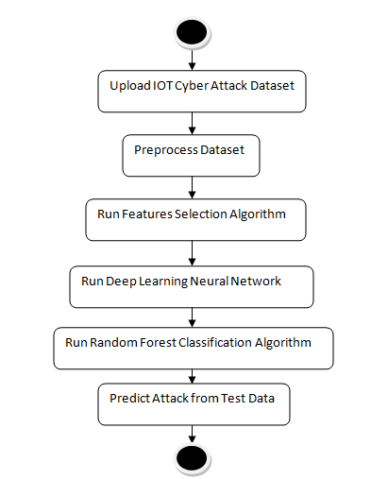

Data flow :
Data flow diagrams illustrate how data is processed by a system in terms of inputs and outputs. Data flow diagrams can be used to provide a clear representation of any business function. The technique starts with an overall picture of the business and continues by analyzing each of the functional areas of interest. This analysis can be carried out in precisely the level of detail required. The technique exploits a method called top-down expansion to conduct the analysis in a targeted way.
As the name suggests, Data Flow Diagram (DFD) is an illustration that explicates the passage of information in a process. A DFD can be easily drawn using simple symbols. Additionally, complicated processes can be easily automated by creating DFDs using easy-to-use, free downloadable diagramming tools. A DFD is a model for constructing and analyzing information processes. DFD illustrates the flow of information in a process depending upon the inputs and outputs. A DFD can also be referred to as a Process Model. A DFD demonstrates business or technical process with the support of the outside data saved, plus the data flowing from the process to another and the end results.
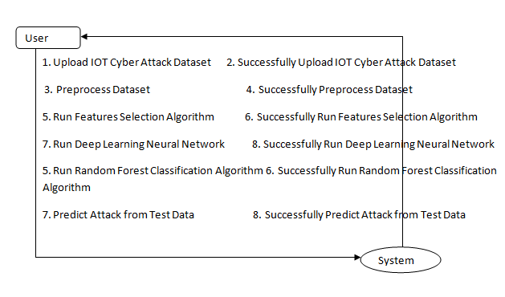

5. IMPLEMETATION
5.1 Python
Python is a general-purpose language. It has wide range of applications from Web development (like: Django and Bottle), scientific and mathematical computing (Orange, SymPy, NumPy) to desktop graphical user Interfaces (Pygame, Panda3D). The syntax of the language is clean and length of the code is relatively short. It's fun to work in Python because it allows you to think about the problem rather than focusing on the syntax.
History of Python:
Python is a fairly old language created by Guido Van Rossum. The design began in the late 1980s and was first released in February 1991.
Why Python was created?
In late 1980s, Guido Van Rossum was working on the Amoeba distributed operating system group. He wanted to use an interpreted language like ABC (ABC has simple easy-to-understand syntax) that could access the Amoeba system calls. So, he decided to create a language that was extensible. This led to design of a new language which was later named Python.
Why the name Python?
No. It wasn't named after a dangerous snake. Rossum was fan of a comedy series from late seventies. The name "Python" was adopted from the same series "Monty Python's Flying Circus".
Features of Python:
A simple language which is easier to learn
Python has a very simple and elegant syntax. It's much easier to read and write Python programs compared to other languages like: C++, Java, C#. Python makes programming fun and allows you to focus on the solution rather than syntax.
If you are a newbie, it's a great choice to start your journey with Python.
Free and open-source
You can freely use and distribute Python, even for commercial use. Not only can you use and distribute software’s written in it, you can even make changes to the Python's source code.
Python has a large community constantly improving it in each iteration.
Portability
You can move Python programs from one platform to another, and run it without any changes.
It runs seamlessly on almost all platforms including Windows, Mac OS X and Linux.
Extensible and Embeddable
Suppose an application requires high performance. You can easily combine pieces of C/C++ or other languages with Python code.
This will give your application high performance as well as scripting capabilities which other languages may not provide out of the box.
A high-level, interpreted language
Unlike C/C++, you don't have to worry about daunting tasks like memory management, garbage collection and so on.
Likewise, when you run Python code, it automatically converts your code to the language your computer understands. You don't need to worry about any lower-level operations.
Large standard libraries to solve common tasks
Python has a number of standard libraries which makes life of a programmer much easier since you don't have to write all the code yourself. For example: Need to connect MySQL database on a Web server? You can use MySQLdb library using import MySQLdb .
Standard libraries in Python are well tested and used by hundreds of people. So you can be sure that it won't break your application.
Object-oriented
Everything in Python is an object. Object oriented programming (OOP) helps you solve a complex problem intuitively.
With OOP, you are able to divide these complex problems into smaller sets by creating objects.
Applications of Python:
1. Simple Elegant Syntax
Programming in Python is fun. It's easier to understand and write Python code. Why? The syntax feels natural. Take this source code for an example:
a = 2
b = 3
sum = a + b
print(sum)
2. Not overly strict
You don't need to define the type of a variable in Python. Also, it's not necessary to add semicolon at the end of the statement.
Python enforces you to follow good practices (like proper indentation). These small things can make learning much easier for beginners.
3. Expressiveness of the language
Python allows you to write programs having greater functionality with fewer lines of code. Here's a link to the source code of Tic-tac-toe game with a graphical interface and a smart computer opponent in less than 500 lines of code. This is just an example. You will be amazed how much you can do with Python once you learn the basics.
4. Great Community and Support
Python has a large supporting community. There are numerous active forums online which can be handy if you are stuck.
ALGORITHM:
Random Forest:
Machine learning, a fascinating blend of computer science and statistics, has witnessed incredible progress, with one standout algorithm being the Random Forest. Random forests or Random Decision Trees is a collaborative team of decision trees that work together to provide a single output. Originating in 2001 through Leo Breiman, Random Forest has become a cornerstone for machine learning enthusiasts. In this article, we will explore the fundamentals and implementation of Random Forest Algorithm.
Random Forest algorithm is a powerful tree learning technique in Machine Learning. It works by creating a number of Decision Trees during the training phase. Each tree is constructed using a random subset of the data set to measure a random subset of features in each partition. This randomness introduces variability among individual trees, reducing the risk of overfitting and improving overall prediction performance. In prediction, the algorithm aggregates the results of all trees, either by voting (for classification tasks) or by averaging (for regression tasks) This collaborative decision-making process, supported by multiple trees with their insights, provides an example stable and precise results. Random forests are widely used for classification and regression functions, which are known for their ability to handle complex data, reduce overfitting, and provide reliable forecasts in different environments.
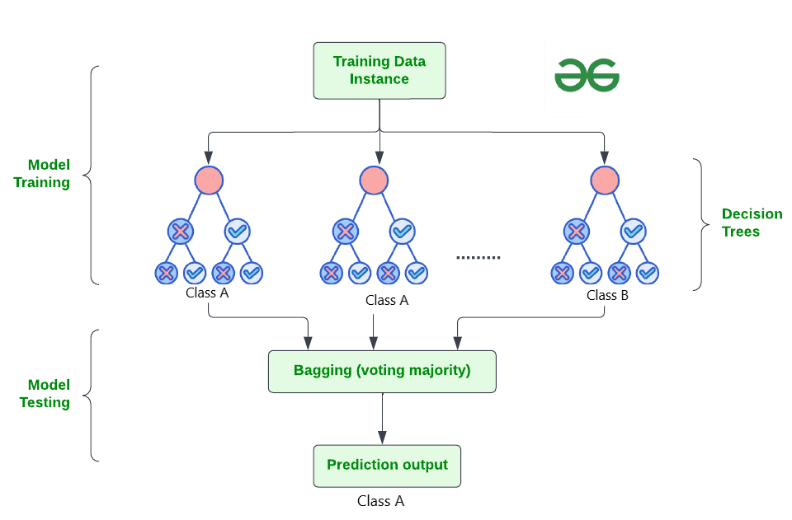

How Does Random Forest Work?
The random Forest algorithm works in several steps which are discussed below–>
- Ensemble of Decision Trees: Random Forest leverages the power of ensemble learning by constructing an army of Decision Trees. These trees are like individual experts, each specializing in a particular aspect of the data. Importantly, they operate independently, minimizing the risk of the model being overly influenced by the nuances of a single tree.
- Random Feature Selection: To ensure that each decision tree in the ensemble brings a unique perspective, Random Forest employs random feature selection. During the training of each tree, a random subset of features is chosen. This randomness ensures that each tree focuses on different aspects of the data, fostering a diverse set of predictors within the ensemble.
- Bootstrap Aggregating or Bagging: The technique of bagging is a cornerstone of Random Forest’s training strategy which involves creating multiple bootstrap samples from the original dataset, allowing instances to be sampled with replacement. This results in different subsets of data for each decision tree, introducing variability in the training process and making the model more robust.
- Decision Making and Voting: When it comes to making predictions, each decision tree in the Random Forest casts its vote. For classification tasks, the final prediction is determined by the mode (most frequent prediction) across all the trees. In regression tasks, the average of the individual tree predictions is taken. This internal voting mechanism ensures a balanced and collective decision-making process.

Key Features of Random Forest
Some of the Key Features of Random Forest are discussed below–>
- High Predictive Accuracy: Imagine Random Forest as a team of decision-making wizards. Each wizard (decision tree) looks at a part of the problem, and together, they weave their insights into a powerful prediction tapestry. This teamwork often results in a more accurate model than what a single wizard could achieve.
- Resistance to Overfitting: Random Forest is like a cool-headed mentor guiding its apprentices (decision trees). Instead of letting each apprentice memorize every detail of their training, it encourages a more well-rounded understanding. This approach helps prevent getting too caught up with the training data which makes the model less prone to overfitting.
- Large Datasets Handling: Dealing with a mountain of data? Random Forest tackles it like a seasoned explorer with a team of helpers (decision trees). Each helper takes on a part of the dataset, ensuring that the expedition is not only thorough but also surprisingly quick.
- Variable Importance Assessment: Think of Random Forest as a detective at a crime scene, figuring out which clues (features) matter the most. It assesses the importance of each clue in solving the case, helping you focus on the key elements that drive predictions.
- Built-in Cross-Validation: Random Forest is like having a personal coach that keeps you in check. As it trains each decision tree, it also sets aside a secret group of cases (out-of-bag) for testing. This built-in validation ensures your model doesn’t just ace the training but also performs well on new challenges.
- Handling Missing Values: Life is full of uncertainties, just like datasets with missing values. Random Forest is the friend who adapts to the situation, making predictions using the information available. It doesn’t get flustered by missing pieces; instead, it focuses on what it can confidently tell us.
- Parallelization for Speed: Random Forest is your time-saving buddy. Picture each decision tree as a worker tackling a piece of a puzzle simultaneously. This parallel approach taps into the power of modern tech, making the whole process faster and more efficient for handling large-scale projects.

Implement Random Forest for Classification :
# Import necessary libraries
import pandas as pd
from sklearn.model_selection import train_test_split
from sklearn.ensemble import RandomForestClassifier
from sklearn.metrics import accuracy_score, classification_report
import warnings
warnings.filterwarnings('ignore')
# Load the Titanic dataset
url = "https://raw.githubusercontent.com/datasciencedojo/datasets/master/titanic.csv"
titanic_data = pd.read_csv(url)
# Drop rows with missing target values
titanic_data = titanic_data.dropna(subset=['Survived'])
# Select relevant features and target variable
X = titanic_data[['Pclass', 'Sex', 'Age', 'SibSp', 'Parch', 'Fare']]
y = titanic_data['Survived']
# Convert categorical variable 'Sex' to numerical using .loc
X.loc[:, 'Sex'] = X['Sex'].map({'female': 0, 'male': 1})
# Handle missing values in the 'Age' column using .loc
X.loc[:, 'Age'].fillna(X['Age'].median(), inplace=True)

# Split the dataset into training and testing sets
X_train, X_test, y_train, y_test = train_test_split(X, y, test_size=0.2, random_state=42)
# Create a Random Forest Classifier
rf_classifier = RandomForestClassifier(n_estimators=100, random_state=42)
# Train the classifier
rf_classifier.fit(X_train, y_train)
# Make predictions on the test set
y_pred = rf_classifier.predict(X_test)
# Evaluate the model
accuracy = accuracy_score(y_test, y_pred)
classification_rep = classification_report(y_test, y_pred)
# Print the results
print(f"Accuracy: {accuracy:.2f}")
print("\nClassification Report:\n", classification_rep)
Output:
Accuracy: 0.80

Classification Report:
precision recall f1-score support

0 0.82 0.85 0.83 105
1 0.77 0.73 0.75 74

accuracy 0.80 179
macro avg 0.79 0.79 0.79 179
weighted avg 0.80 0.80 0.80 179

In the above code, we’re using a Random Forest Classifier to make sense of the Titanic dataset. First, we gather our tools – importing libraries to handle data and evaluate our model. Next, we dive into the Titanic dataset, fixing missing information and choosing important details like a detective solving a mystery. We even teach the computer to understand ‘male’ and ‘female’ by turning them into numbers. Then, we split our dataset into pieces – one part to train our model, and the other to test its newfound skills. Our Random Forest Classifier is like a student, learning from the training set. Once trained, it faces a test – making predictions on the test set. We’re like judges, using a classification report to grade how well our model did.
5.2 Sample Code:
from tkinter import *
import tkinter
from tkinter import filedialog
import matplotlib.pyplot as plt
from tkinter.filedialog import askopenfilename
import numpy as np
from sklearn.metrics import accuracy_score
from sklearn.model_selection import train_test_split
from sklearn.metrics import confusion_matrix
import seaborn as sns
from sklearn.metrics import precision_score
from sklearn.metrics import recall_score
from sklearn.metrics import f1_score
import os
from sklearn.ensemble import RandomForestClassifier

import pandas as pd
from sklearn.impute import SimpleImputer
from sklearn.preprocessing import LabelEncoder
from sklearn.preprocessing import StandardScaler
from sklearn.ensemble import RandomForestClassifier
from sklearn.metrics import accuracy_score
from sklearn.neural_network import MLPClassifier
from sklearn.decomposition import PCA

main = tkinter.Tk()
main.title("DETECTION OF CYBER ATTACKS TRACES IN IOT DATA")
main.geometry("1200x1200")

global X_train, X_test, y_train, y_test, pca, classifier
global dataset
global filename
global X, Y, label_encoder, imputer, imputer1
sc = StandardScaler()

labels = ['anomalous(DoSattack)', 'anomalous(dataProbing)', 'anomalous(malitiousControl)', 'anomalous(malitiousOperation)',
'anomalous(scan)', 'anomalous(spying)', 'anomalous(wrongSetUp)', 'normal']

def uploadDataset():
global filename, dataset
text.delete('1.0', END)
filename = filedialog.askopenfilename(initialdir="Dataset")
text.insert(END,str(filename)+" Dataset Loaded\n\n")
pathlabel.config(text=str(filename)+" Dataset Loaded\n\n")
dataset = pd.read_csv(filename)
dataset.fillna(0, inplace = True)
text.insert(END,str(dataset.head()))

def preprocessDataset():
global X, Y, label_encoder, sc, dataset, imputer, imputer1
label_encoder = []
text.delete('1.0', END)
X = dataset.iloc[:,:-2].values
Y = dataset.iloc[:,12].values
label_encoder = []
for i in range(0,11):
le = LabelEncoder()
X[:,i] = le.fit_transform(X[:,i].astype(str))
label_encoder.append(le)
imputer = SimpleImputer(missing_values=np.nan,strategy='constant',verbose=0)
imputer = imputer.fit(X[:,[8]])
X[:,[8]] = imputer.transform(X[:,[8]])
imputer1 = SimpleImputer(missing_values=np.nan,strategy='mean',verbose=0)
imputer1 = imputer1.fit(X[:,[10]])
X[:,[10]] = imputer1.transform(X[:,[10]])
X = np.array(X,dtype=np.float)
X = sc.fit_transform(X)
Y_le = LabelEncoder()
Y = Y_le.fit_transform(Y)
indices = np.arange(X.shape[0])
np.random.shuffle(indices)
X = X[indices]
Y = Y[indices]
text.insert(END,str(X)+"\n\n")
text.insert(END,"Total records found in dataset: "+str(X.shape[0])+"\n\n")
text.insert(END,"Total features found in dataset before apply PCA features selection: "+str(X.shape[1])+"\n\n")
text.insert(END,"Different Security & Privacy attack found in dataset\n\n")
text.insert(END,str(labels))

def featureSelection():
global X_train, X_test, y_train, y_test
global X, Y, pca
text.delete('1.0', END)
pca = PCA(n_components = 10)
X = pca.fit_transform(X)
text.insert(END,"Total features found in dataset after apply PCA features selection: "+str(X.shape[1])+"\n\n")
X_train, X_test, y_train, y_test = train_test_split(X, Y, test_size=0.2, random_state=0)
text.insert(END,"Dataset training and testing split details\n")
text.insert(END,"Dataset size: "+str(X.shape[0])+"\n")
text.insert(END,"80% dataset used for training: "+str(X_train.shape[0])+"\n")
text.insert(END,"20% dataset used for testing: "+str(X_test.shape[0])+"\n")

def runNeuralNetwork():
global X, Y
global X_train, X_test, y_train, y_test

text.delete('1.0', END)
classifier = MLPClassifier()
classifier.fit(X, Y)
y_pred = classifier.predict(X_test)
accuracy = accuracy_score(y_test, y_pred)
text.insert(END,"Deep Learning Neural Network Prediction Accuracy: "+str(accuracy)+"\n\n")

conf_matrix = confusion_matrix(y_test, y_pred)
plt.figure(figsize =(6, 6))
ax = sns.heatmap(conf_matrix, xticklabels = labels, yticklabels = labels, annot = True, cmap="viridis" ,fmt ="g");
ax.set_ylim([0,len(labels)])
plt.title("Deep Learning Neural Network Classification Confusion matrix")
plt.ylabel('True class')
plt.xlabel('Predicted class')
plt.show()

def runRandomForest():
global X_train, X_test, y_train, y_test, classifier
global X, Y, pca

classifier = RandomForestClassifier(n_estimators=10, criterion='entropy', random_state=0)
classifier.fit(X_train, y_train)
y_pred = classifier.predict(X_test)
accuracy = accuracy_score(y_test, y_pred)
text.insert(END,"Random Forest Test Data Prediction Accuracy: "+str(accuracy)+"\n\n")

conf_matrix = confusion_matrix(y_test, y_pred)
plt.figure(figsize =(6, 6))
ax = sns.heatmap(conf_matrix, xticklabels = labels, yticklabels = labels, annot = True, cmap="viridis" ,fmt ="g");
ax.set_ylim([0,len(labels)])
plt.title("Random Foresr Classification Confusion matrix")
plt.ylabel('True class')
plt.xlabel('Predicted class')
plt.show()

def predict():
global pca, sc, classifier, label_encoder, imputer, imputer1
text.delete('1.0', END)
testFile = filedialog.askopenfilename(initialdir="Dataset")
dataset = pd.read_csv(testFile)
dataset.fillna(0, inplace = True)
test = dataset.iloc[:,:-1].values
display = test

for i in range(0,11):
test[:,i] = label_encoder[i].transform(test[:,i].astype(str))
test[:,[8]] = imputer.transform(test[:,[8]])
test[:,[10]] = imputer1.transform(test[:,[10]])
test = np.array(test,dtype=np.float)
test = sc.transform(test)
test = pca.transform(test)
predict = classifier.predict(test)
print(predict.tolist())
for i in range(len(display)):
text.insert(END,"Test IOT Traffic: "+str(display[i])+" =====> Predicted As: "+labels[predict[i]]+"\n\n")

def close():
main.destroy()

font = ('times', 14, 'bold')
title = Label(main, text='DETECTION OF CYBER ATTACKS TRACES IN IOT DATA')
title.config(bg='DarkGoldenrod1', fg='black')
title.config(font=font)
title.config(height=3, width=120)
title.place(x=5,y=5)

font1 = ('times', 12, 'bold')
uploadButton = Button(main, text="Upload IOT Cyber Attack Dataset", command=uploadDataset)
uploadButton.place(x=50,y=100)
uploadButton.config(font=font1)

pathlabel = Label(main)
pathlabel.config(bg='brown', fg='white')
pathlabel.config(font=font1)
pathlabel.place(x=560,y=100)

preprocessButton = Button(main, text="Preprocess Dataset", command=preprocessDataset)
preprocessButton.place(x=50,y=150)
preprocessButton.config(font=font1)

hybridMLButton = Button(main, text="Run Features Selection Algorithm", command=featureSelection)
hybridMLButton.place(x=50,y=200)
hybridMLButton.config(font=font1)

snButton = Button(main, text="Run Deep Learning Neural Network", command=runNeuralNetwork)
snButton.place(x=50,y=250)
snButton.config(font=font1)

snButton = Button(main, text="Run Random Forest Classification Algorithm", command=runRandomForest)
snButton.place(x=50,y=300)
snButton.config(font=font1)

graphButton = Button(main, text="Predict Attack from Test Data", command=predict)
graphButton.place(x=50,y=350)
graphButton.config(font=font1)

exitButton = Button(main, text="Exit", command=close)
exitButton.place(x=50,y=400)
exitButton.config(font=font1)

font1 = ('times', 12, 'bold')
text=Text(main,height=25,width=100)
scroll=Scrollbar(text)
text.configure(yscrollcommand=scroll.set)
text.place(x=400,y=150)
text.config(font=font1)

main.config(bg='LightSteelBlue1')
main.mainloop()

6. TESTING:
Implementation and Testing:
Implementation is one of the most important tasks in project is the phase in which one has to be cautions because all the efforts undertaken during the project will be very interactive. Implementation is the most crucial stage in achieving successful system and giving the users confidence that the new system is workable and effective. Each program is tested individually at the time of development using the sample data and has verified that these programs link together in the way specified in the program specification. The computer system and its environment are tested to the satisfaction of the user.

Implementation

The implementation phase is less creative than system design. It is primarily concerned with user training, and file conversion. The system may be requiring extensive user training. The initial parameters of the system should be modifies as a result of a programming. A simple operating procedure is provided so that the user can understand the different functions clearly and quickly. The different reports can be obtained either on the inkjet or dot matrix printer, which is available at the disposal of the user. The proposed system is very easy to implement. In general implementation is used to mean the process of converting a new or revised system design into an operational one.

Testing
Testing is the process where the test data is prepared and is used for testing the modules individually and later the validation given for the fields. Then the system testing takes place which makes sure that all components of the system property functions as a unit. The test data should be chosen such that it passed through all possible condition. Actually testing is the state of implementation which aimed at ensuring that the system works accurately and efficiently before the actual operation commence. The following is the description of the testing strategies, which were carried out during the testing period.

System Testing
Testing has become an integral part of any system or project especially in the field of information technology. The importance of testing is a method of justifying, if one is ready to move further, be it to be check if one is capable to with stand the rigors of a particular situation cannot be underplayed and that is why testing before development is so critical. When the software is developed before it is given to user to use the software must be tested whether it is solving the purpose for which it is developed. This testing involves various types through which one can ensure the software is reliable. The program was tested logically and pattern of execution of the program for a set of data are repeated. Thus the code was exhaustively checked for all possible correct data and the outcomes were also checked.
Module Testing
To locate errors, each module is tested individually. This enables us to detect error and correct it without affecting any other modules. Whenever the program is not satisfying the required function, it must be corrected to get the required result. Thus all the modules are individually tested from bottom up starting with the smallest and lowest modules and proceeding to the next level. Each module in the system is tested separately. For example the job classification module is tested separately. This module is tested with different job and its approximate execution time and the result of the test is compared with the results that are prepared manually. The comparison shows that the results proposed system works efficiently than the existing system. Each module in the system is tested separately. In this system the resource classification and job scheduling modules are tested separately and their corresponding results are obtained which reduces the process waiting time.
Integration Testing
After the module testing, the integration testing is applied. When linking the modules there may be chance for errors to occur, these errors are corrected by using this testing. In this system all modules are connected and tested. The testing results are very correct. Thus the mapping of jobs with resources is done correctly by the system.

Acceptance Testing
When that user fined no major problems with its accuracy, the system passers through a final acceptance test. This test confirms that the system needs the original goals, objectives and requirements established during analysis without actual execution which elimination wastage of time and money acceptance tests on the shoulders of users and management, it is finally acceptable and ready for the operation.

Test Case Id | Test Case Name | Test Case Desc. | Test Steps |  |  |  | Test Case Status | Test Priority
 |  |  | Step | Expected |  | Actual
01 | Upload IOT Cyber Attack Dataset | Verify Upload IOT Cyber Attack Dataset or not | If IOT Cyber Attack Dataset may not upload | we cannot do any further operations | we can do further operations |  | High | High
02 | Dataset Preprocessing | Verify Dataset Preprocessing or not | If Dataset Preprocessing may not upload | we cannot do any further operations | we can do further operations |  | High | High
03 | Run Features Selection Algorithm | Verify Run Features Selection Algorithm or not | If Features Selection Algorithm May not be Run | we cannot do any further operations | we can do further operations |  | High | High
04 | Run Deep Learning Neural Network | Verify Run Deep Learning Neural Networkor not | If Deep Learning Neural Network May not Run | We cannot run  operation | We can Run the Operation |  | High | High
05 | Run Random Forest Classification Algorithm | Verify Run Random Forest Classification Algorithm or not | If Random Forest Classification Algorithm May not be Run | we cannot do any further operations | we can do further operations |  | High | High
06 | Predict Attack from Test Data | Verify Predict Attack from Test Data or not | If Attack from Test Data May not predicted | We cannot run  operation | We can Run the Operation |  | High | High
7. SCREENSHOTS:
In this project author is applying Machine Learning Neural Network algorithm to detect attacks from IOT networks as IOT are small devices which will sense data from environment and using internet connection will send sense data to base station or centralized servers and sometime attackers may hijack or intrude the data transfer and inject false or incorrect information and to overcome from this problem we are training Neural Network algorithm with IOT traces dataset and whenever new test packet arrived then neural network will predict whether that packet is normal or contain attack signatures.
We are using below smart home IOT dataset to train neural network
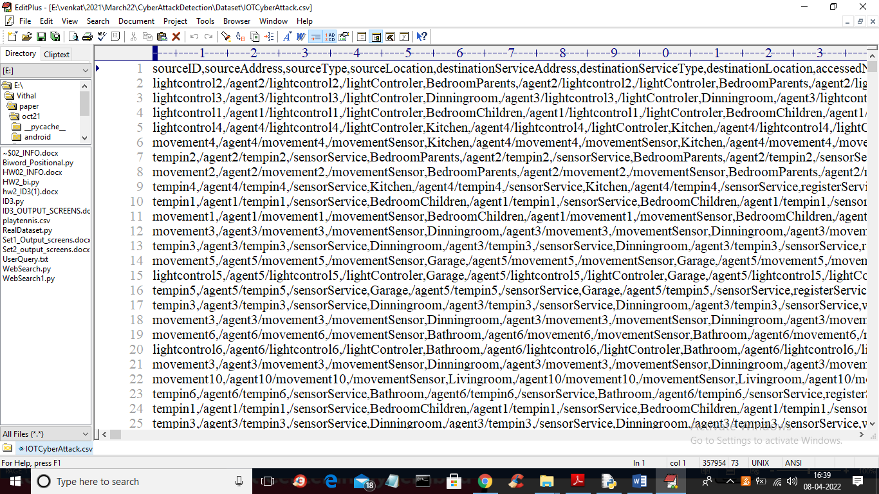
In above dataset screen first row contains dataset column names and remaining are the dataset values from IOT devices and each row contains class label as NORMAL or attack.
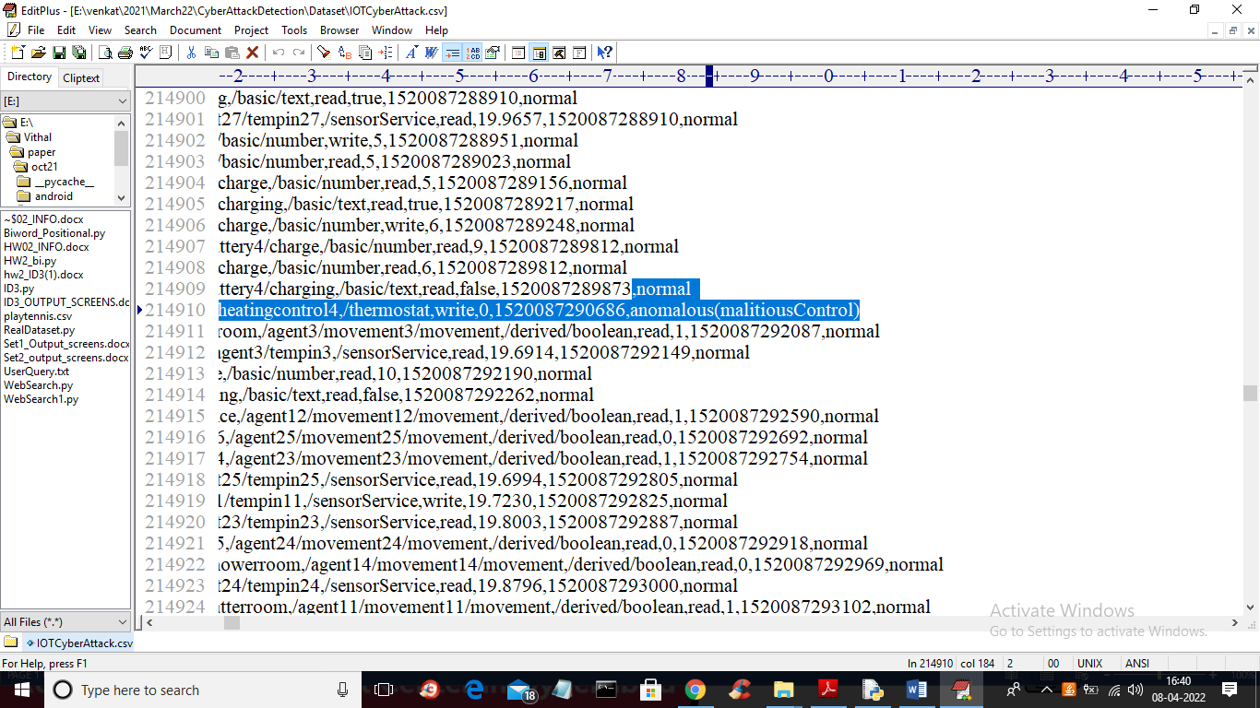
In above screen in last column we can see each packet contains class label as normal or malicious attack and we will use this dataset to train neural network algorithms.
SCREEN SHOTS
To run project double click on ‘run.bat’ file to get below output
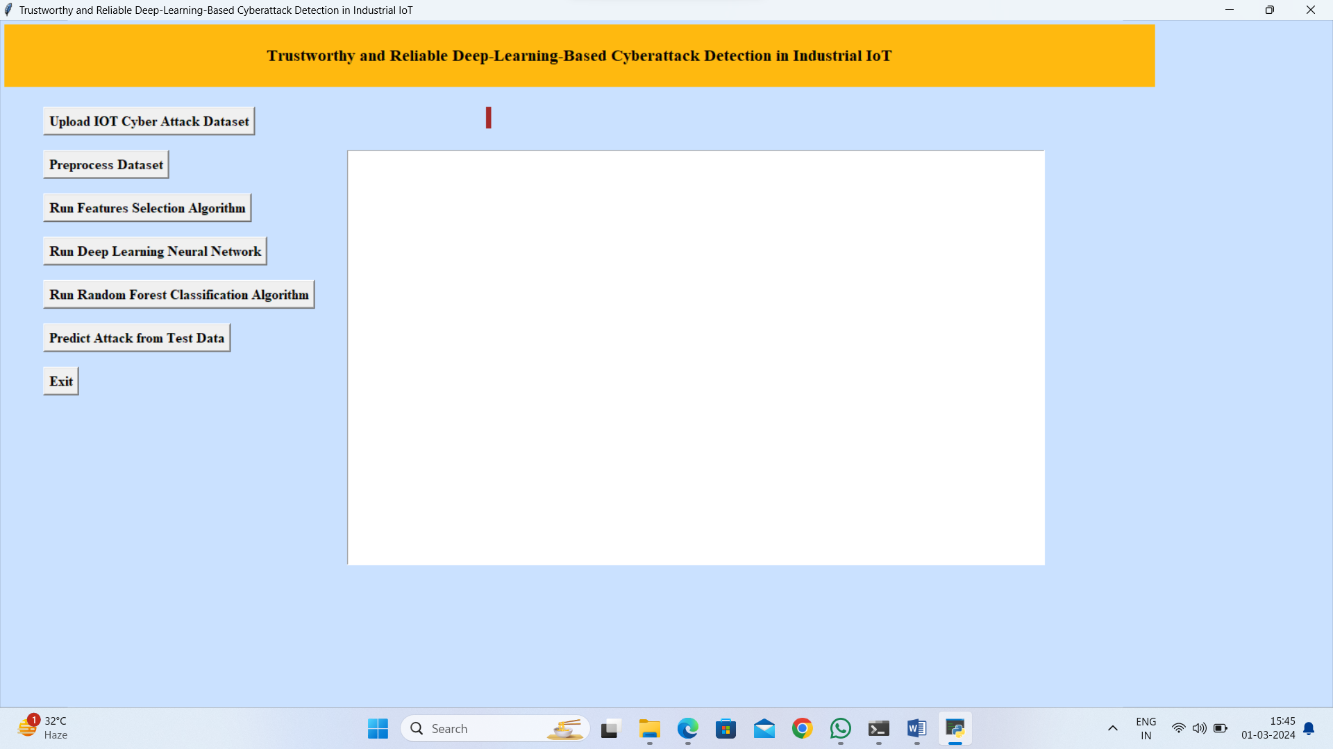
In above screen click on ‘Upload IOT Cyber Attack Dataset’ button to upload dataset and to get below output
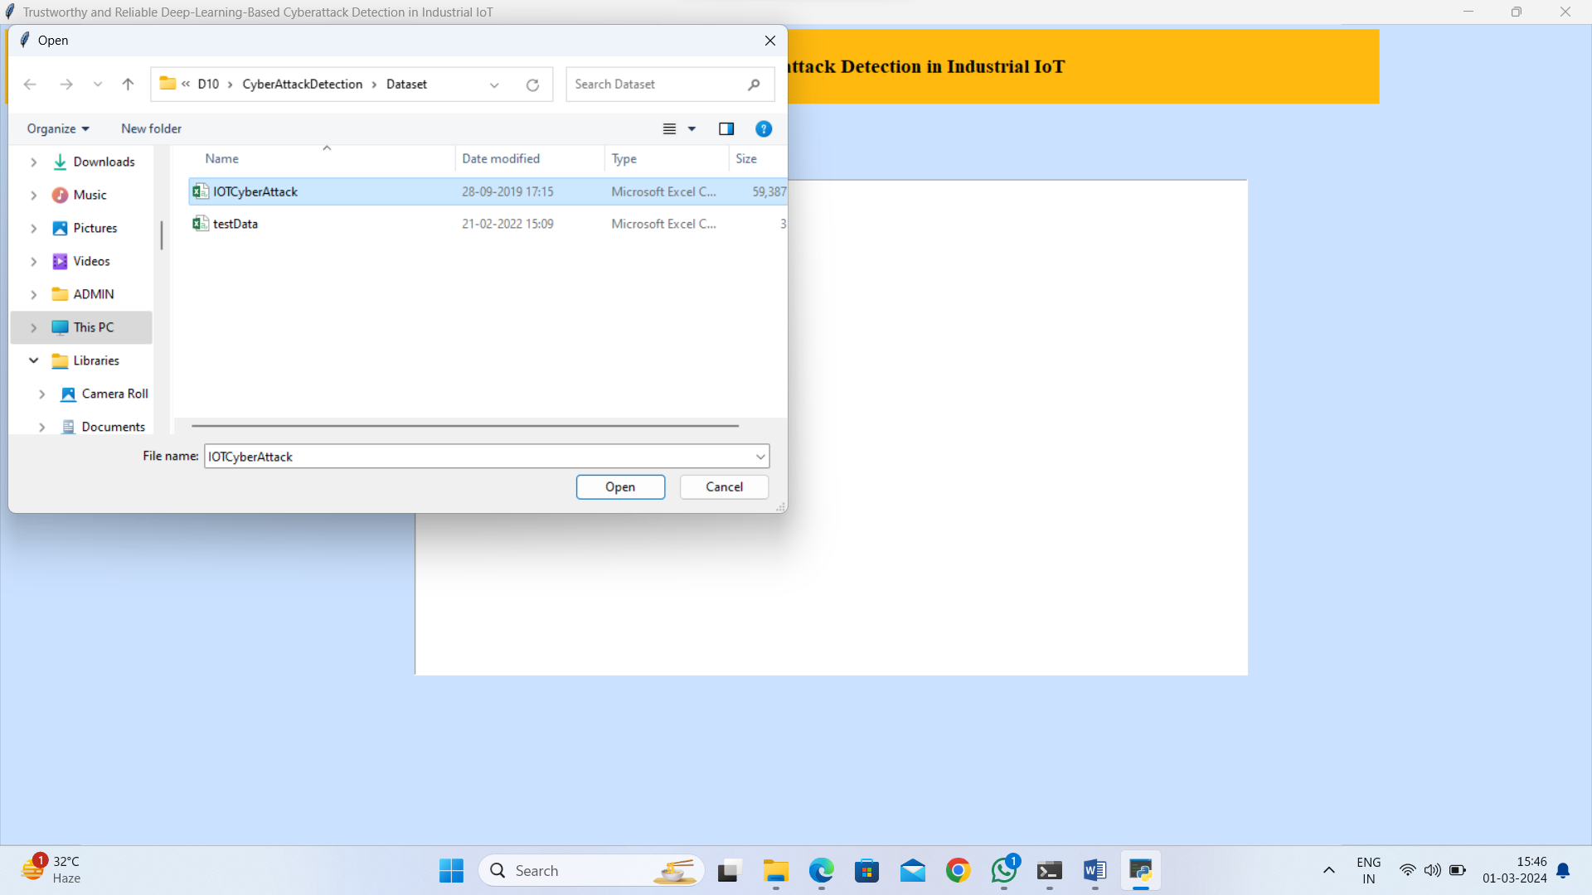
In above screen selecting and uploading ‘IOT cyber Attack’ dataset and then click on ‘Open’ button to load dataset and to get below output
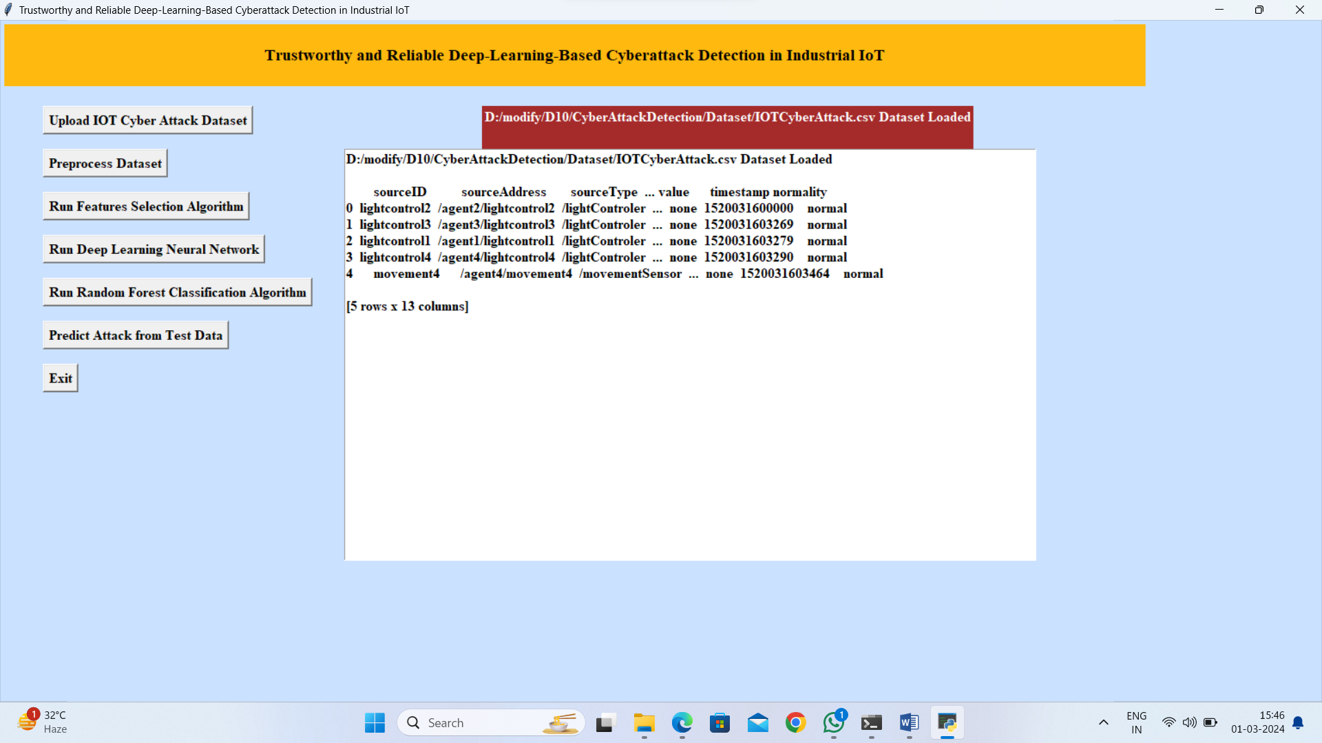
In above screen dataset loaded but we can see dataset contains some non-numeric data so we need to click on ‘Preprocess Dataset’ button to convert non-numeric data to numeric and get below output
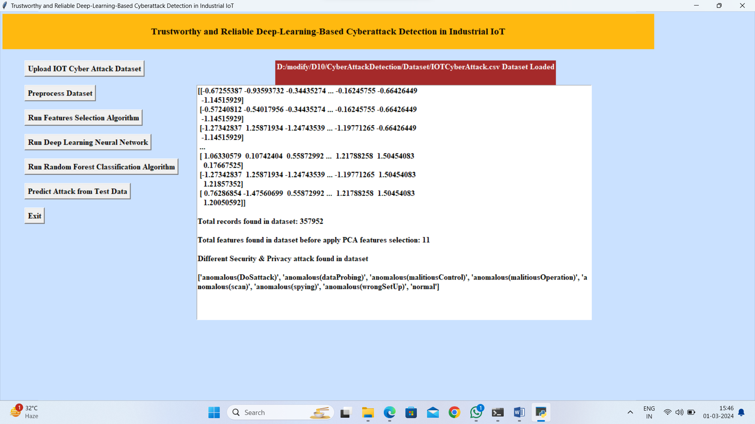
In above screen we can see all values converted to numeric format and in blue colour text we can see different attacks found in dataset and we can see before applying PCA dataset contains 11 attributes and now click on ‘Run Features Selection Algorithm’ button to select important features by applying PCA algorithm and get below output
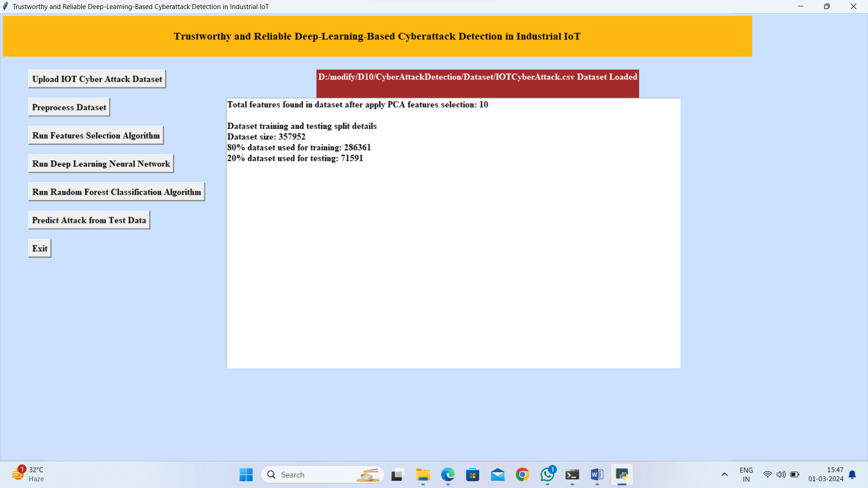
In above screen we can see after applying PCA dataset features reduced to 10 and we can see dataset contains 357952 records and application using 286361 (80%) records for training and 71591 (20%) records for testing and now dataset train and test part is ready and now click on ‘Run Deep Learning Neural Network’ button to train neural network and get below accuracy
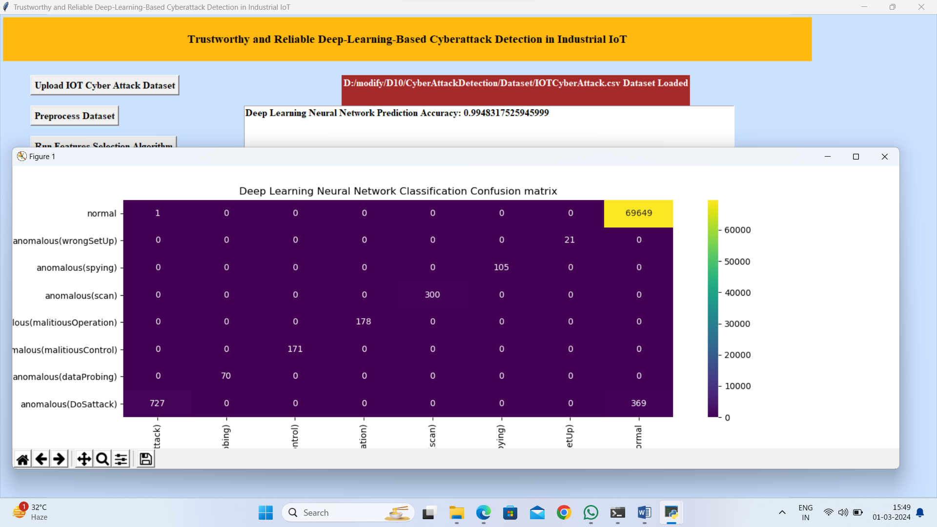
In above screen with neural network we got 0.99% accuracy and in confusion matrix graph x-axis represents predicted attacks and y-axis represents True dataset class and in diagnol of graph we can see all test data is correctly predicted. Now close above graph and then click on ‘Run Random Forest Classification Algorithm’ button to train Random Forest and get below output
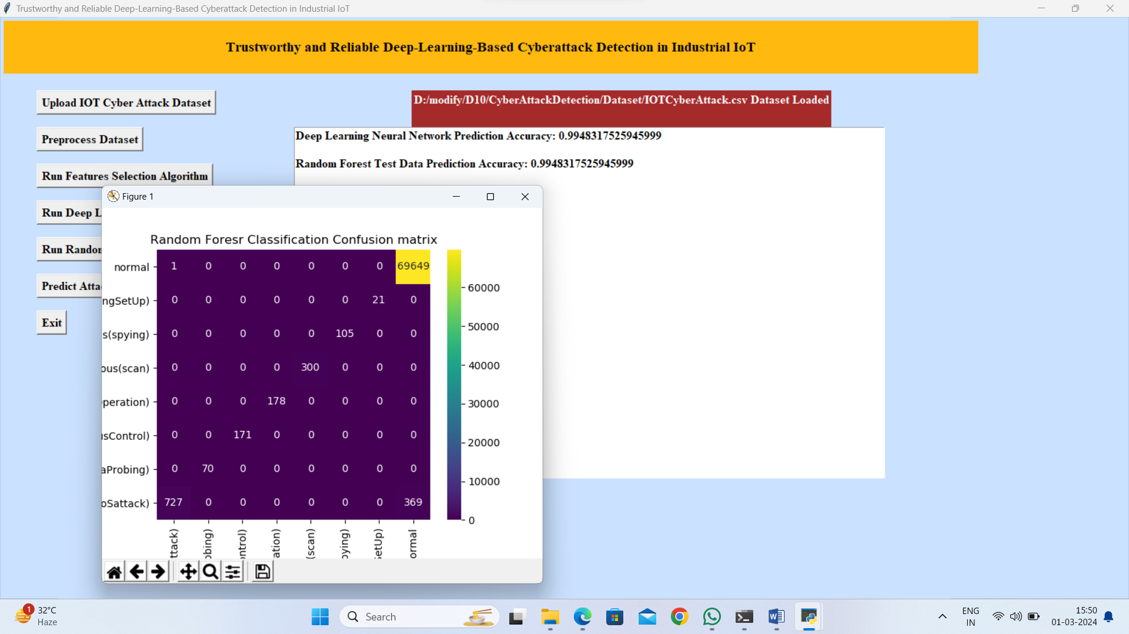
In above screen with random forest also we got nearer accuracy but Neural network is higher and now close above graph and then click on ‘Predict Attack from Test Data’ button to upload test data and get below prediction output
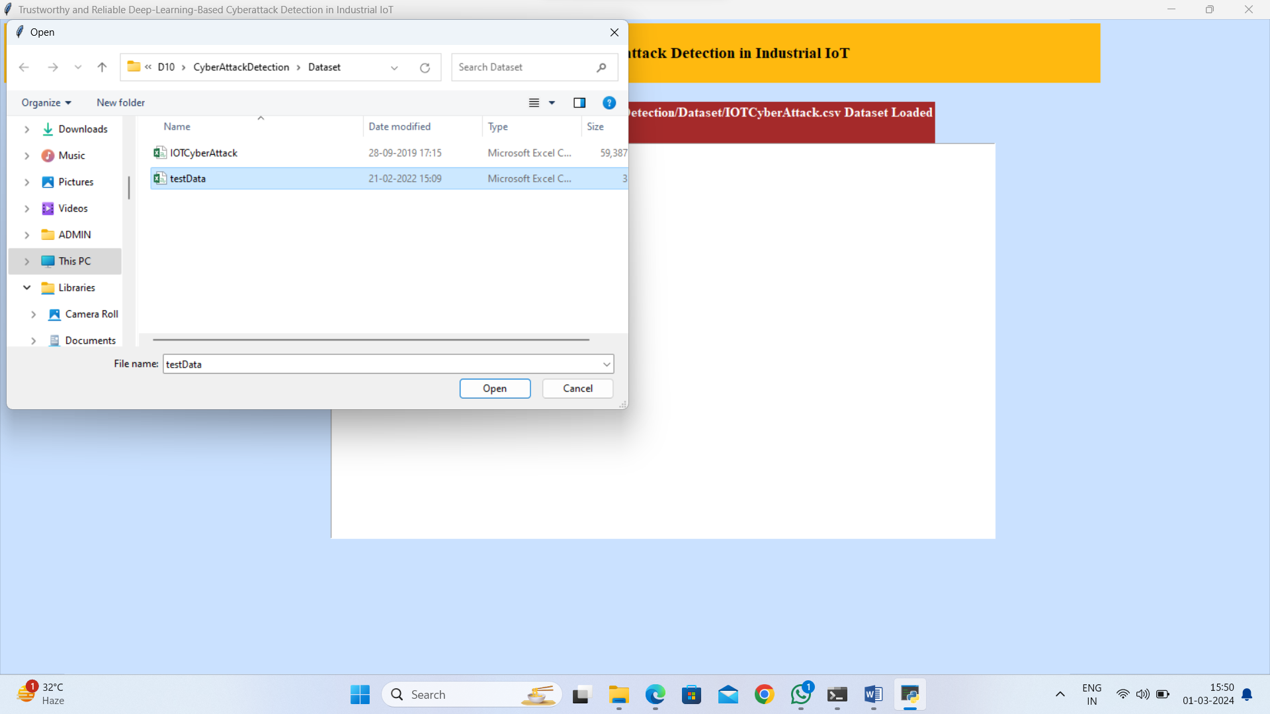
In above screen selecting and uploading ‘testData.csv’ file and then click on ‘Open’ button to get below output
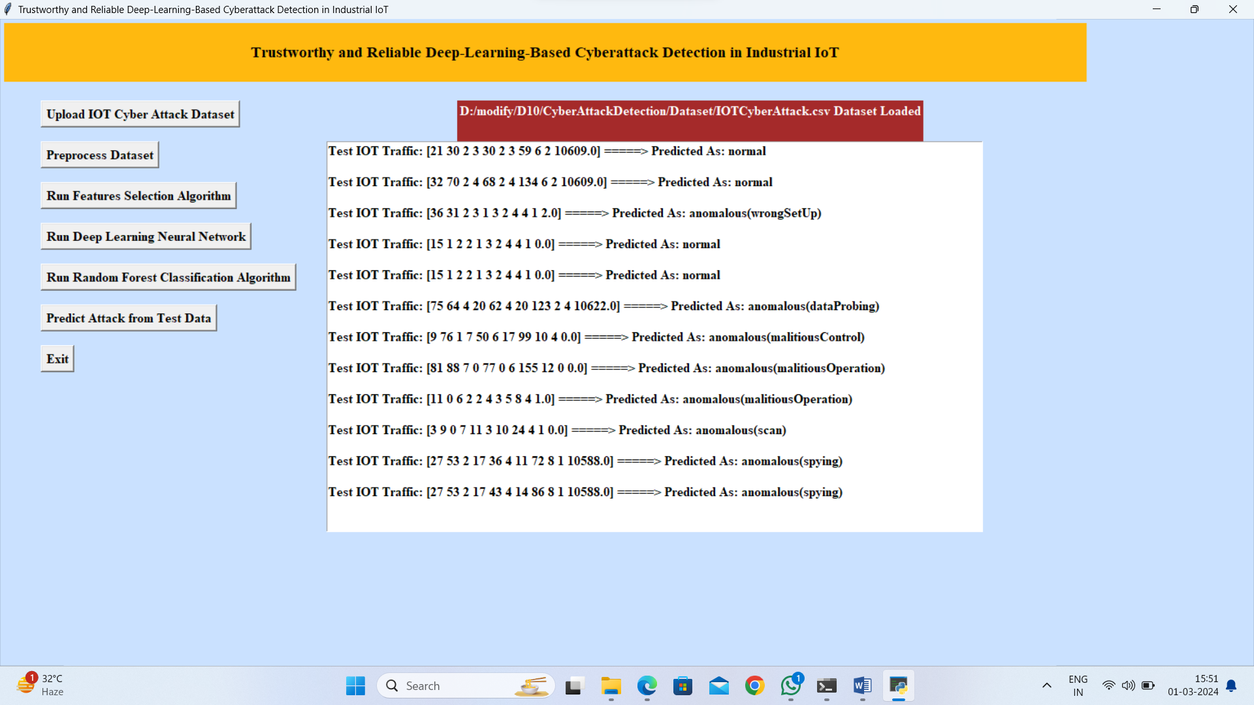
In above screen in square bracket we can see IOT traces data and after arrow symbol we can see predicted output as NORMAL or attack name. So by using machine learning algorithm we can predict 99% attacks accurately

8. CONCLUSION:
For large and heterogeneous datasets like the IoT-23, DAE proves useful in learning and provides feature representation suitable for ML algorithms. The conducted experiments indicated that the use of the DAE as a feature extractor in conjunction with deep learning in the form of the proposed mLSTM in the role of a classifier offers improvements when the performance on the IoT benchmark is measured. The experimental results and statistical significance tests illustrate that the proposed method is an improvement over the individual baseline classifiers including Random Forest and Support Vector Machine on the used novel IoT benchmark, reaching the accuracy of 99.9% and g-mean score 97.1%, respectively. Considering future work, our study will attempt to apply a lifelong learning approach to deep learning algorithms to facilitate better detection of novel attacks, and its is expected to be further extended to conduct experiments on modern and more sophisticated datasets. Finally, security of the deep learning model against adversarial attacks needs to be provided
9. REFERENCES:
- [Abolhasanzadeh, 2015] Abolhasanzadeh, B. (2015). Nonlinear dimensionality reduction for intrusion detection using auto-encoder bottleneck features. In 2015 7th Conference on Information and Knowledge Technology (IKT), pages 1–5. IEEE.
- [Agustin et al., 2020] Agustin, P., Sebastian, G., and Maria Jose, E. (2020 (accessed February 3, 2020)). Stratosphere laboratory. a labeled dataset with malicious and benign iot network traffic. https://www.stratosphereips.org/datasets-iot23.
- [Al-Qatf et al., 2018] Al-Qatf, M., Lasheng, Y., Al-Habib, M., and Al-Sabahi, K. (2018). Deep learning approach combining sparse autoencoder with svm for network intrusion detection. IEEE Access, 6:52843–52856.
- [Arel et al., 2009] Arel, I., Rose, D., and Coop, R. (2009). Destin: A scalable deep learning architecture with application to high-dimensional robust pattern recognition. In 2009 AAAI Fall Symposium Series.
- [Barut et al., 2020] Barut, O., Luo, Y., Zhang, T., Li, W., and Li, P. (2020). Netml: A challenge for network traffic analytics. arXiv preprint arXiv:2004.13006.
- [Berman et al., 2019] Berman, D., Buczak, A., Chavis, J., and Corbett, C. (2019). A Survey of Deep Learning Methods for Cyber Security. Information, 10(4):122.
- [Bieniasz et al., 2019] Bieniasz, J., Stepkowska, M., Janicki, A., and Szczypiorski, K. (2019). Mobile agents for detecting network attacks using timing covert channels. J. UCS, 25(9):1109–1130.
- [Bobowska et al., 2018] Bobowska, B., Choras, M., and Wozniak, M. (2018). Advanced analysis of data streams for critical infrastructures protection and cybersecurity. J. UCS, 24(5):622–633.
- [da Costa et al., 2019] da Costa, K. A., Papa, J. P., Lisboa, C. O., Munoz, R., and de Albuquerque, V. H. C. (2019). Internet of things: A survey on machine learningbased intrusion detection approaches. Computer Networks, 151:147–157.
- [D’Angelo et al., 2020] D’Angelo, G., Ficco, M., and Palmieri, F. (2020). Malware detection in mobile environments based on Autoencoders and API-images. Journal of Parallel and Distributed Computing, 137:26–33.
- D’Angelo and Palmieri, 2021] D’Angelo, G. and Palmieri, F. (2021). Network traffic classification using deep convolutional recurrent autoencoder neural networks for spatial–temporal features extraction. Journal of Network and Computer Applications, 173:102890.
- [D’Angelo et al., 2019] D’Angelo, G., Palmieri, F., and Rampone, S. (2019). Detecting unfair recommendations in trust-based pervasive environments. Information Sciences, 486:31–51. [Dhanabal and Shantharajah, 2015] Dhanabal, L. and Shantharajah, S. (2015). A study on nsl-kdd dataset for intrusion detection system based on classification algorithms. International Journal of Advanced Research in Computer and Communication Engineering, 4(6):446–452.
- [Dutta et al., 2020a] Dutta, V., Chora´s, M., Pawlicki, M., and Kozik, R. (2020a). A Deep Learning Ensemble for Network Anomaly and Cyber-Attack Detection. Sensors, 20(16):4583.
- [Dutta et al., 2020b] Dutta, V., Chora´s, M., Pawlicki, M., and Kozik, R. (2020b). Hybrid model for improving the classification effectiveness of network intrusion detection. In Conference on Complex, Intelligent, and Software Intensive Systems. Springer.
- [Ektefa et al., 2010] Ektefa, M., Memar, S., Sidi, F., and Affendey, L. S. (2010). Intrusion detection using data mining techniques. In 2010 International Conference on Information Retrieval & Knowledge Management (CAMP), pages 200–203. IEEE.
- [Esp´ındola and Ebecken, 2005] Esp´ındola, R. and Ebecken, N. (2005). On extending f-measure and g-mean metrics to multi-class problems. Sixth international conference on data mining, text mining and their business applications, 35:25–34.
- [Ferrag et al., 2020] Ferrag, M. A., Maglaras, L., Moschoyiannis, S., and Janicke, H. (2020). Deep learning for cyber security intrusion detection: Approaches, datasets, and comparative study. Journal of Information Security and Applications, 50:102419.
- [Gao et al., 2020] Gao, M., Ma, L., Liu, H., Zhang, Z., Ning, Z., and Xu, J. (2020). Malicious network traffic detection based on deep neural networks and association analysis. Sensors, 20(5):1452.
- [Goeschel, 2016] Goeschel, K. (2016). Reducing false positives in intrusion detection systems using data-mining techniques utilizing support vector machines, decision trees, and naive bayes for off-line analysis. In SoutheastCon 2016, pages 1–6. IEEE.
- [Hodo et al., 2017] Hodo, E., Bellekens, X., Hamilton, A., Tachtatzis, C., and Atkinson, R. (2017). Shallow and deep networks intrusion detection system: A taxonomy and survey. arXiv preprint arXiv:1701.02145.
- [Jin Kim et al., 2017] Jin Kim, Nara Shin, Jo, S. Y., and Sang Hyun Kim (2017). Method of intrusion detection using deep neural network. In 2017 IEEE International Conference on Big Data and Smart Computing (BigComp), pages 313–316. IEEE.
- [Kim et al., 2016] Kim, J., Kim, J., Thu, H. L. T., and Kim, H. (2016). Long short term memory recurrent neural network classifier for intrusion detection. In 2016 International Conference on Platform Technology and Service (PlatCon), pages 1–5. IEEE.
- [Komisarek et al., 2020] Komisarek, M., Choras, M., Kozik, R., and Pawlicki, M. (2020). Real-time stream processing tool for detecting suspicious network patterns using machine learning. ARES conference.
- [Kozik and Chora´s, 2017] Kozik, R. and Chora´s, M. (2017). Pattern extraction algorithm for netflow-based botnet activities detection. Security and Communication Networks.
- [Ksieniewicz and Wo´zniak, 2018] Ksieniewicz, P. and Wo´zniak, M. (2018). Imbalanced data classification based on feature selection techniques. In International Conference on Intelligent Data Engineering and Automated Learning, pages 296–303. Springer.
- [Liu and Lang, 2019] Liu, H. and Lang, B. (2019). Machine learning and deep learning methods for intrusion detection systems: A survey. Applied Sciences, 9(20):4396.
- [Lopez-Martin et al., 2017] Lopez-Martin, M., Carro, B., Sanchez-Esguevillas, A., and Lloret, J. (2017). Network Traffic Classifier With Convolutional and Recurrent Neural Networks for Internet of Things. IEEE Access, 5:18042–18050.
- [Panda et al., 2012] Panda, M., Abraham, A., and Patra, M. R. (2012). A hybrid intelligent approach for network intrusion detection. Procedia Engineering, 30:1–9.
- [Pawlicki et al., 2020] Pawlicki, M., Chora´s, M., and Kozik, R. (2020). Defending network intrusion detection systems against adversarial evasion attacks. Future Generation Computer Systems.
- [Potluri et al., 2018] Potluri, S., Ahmed, S., and Diedrich, C. (2018). Convolutional neural networks for multi-class intrusion detection system. In International Conference on Mining Intelligence and Knowledge Exploration, pages 225–238. Springer.
- [Rend´on et al., 2020] Rend´on, E., Alejo, R., Castorena, C., Isidro-Ortega, F. J., and Granda-Guti´errez, E. E. (2020). Data sampling methods to deal with the big data multi-class imbalance problem. Applied Sciences, 10(4):1276.
- [Roy et al., 2017] Roy, S. S., Mallik, A., Gulati, R., Obaidat, M. S., and Krishna, P. V. (2017). A deep learning based artificial neural network approach for intrusion detection. In International Conference on Mathematics and Computing, pages 44–53. Springer.
- [Topolski, 2020] Topolski, M. (2020). Application of the stochastic gradient method in the construction of the main components of pca in the task diagnosis of multiple sclerosis in children. In Krzhizhanovskaya, V. V., Z´avodszky, G., Lees, M. H., Dongarra, J. J., Sloot, P. M. A., Brissos, S., and Teixeira, J., editors, Computational Science – ICCS 2020, pages 35–44, Cham. Springer International Publishing.
- [Torres et al., 2016] Torres, P., Catania, C., Garcia, S., and Garino, C. G. (2016). An analysis of recurrent neural networks for botnet detection behavior. In 2016 IEEE biennial congress of Argentina (ARGENCON), pages 1–6. IEEE.
- [Yan and Han, 2018] Yan, B. and Han, G. (2018). Effective feature extraction via stacked sparse autoencoder to improve intrusion detection system. IEEE Access, 6:41238–41248.
- [Zhang et al., 2018] Zhang, C., Cheng, X., Liu, J., He, J., and Liu, G. (2018). Deep sparse autoencoder for feature extraction and diagnosis of locomotive adhesion status. Journal of Control Science and Engineering, 2018.
- [Zhao et al., 2017] Zhao, R., Yan, R., Wang, J., and Mao, K. (2017). Learning to monitor machine health with convolutional bi-directional lstm networks. Sensors, 17(2):273.
- [Zong et al., 2020] Zong, W., Chow, Y.-W., and Susilo, W. (2020). Interactive threedimensional visualization of network intrusion detection data for machine learning. Future Generation Computer Systems, 102:292–306.

